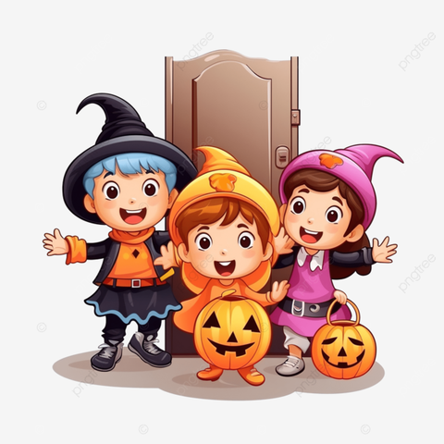

**Please use these guidelines when planning costumes for children as well as volunteers attending our parade and parties. These guidelines are meant to help our Halloween celebration be respectful, responsible, safe, and inclusive for all.**

* **Costumes should be family friendly. They may not be gory, immodest, threatening, or offensive.**
* **No masks.**
* **Students may not carry hand-held accessories, real or pretend (i.e., wands, weapons, etc.).**
* **Crowns or hats may be worn.**
* **Costumes must avoid stereotypes of ethnic or cultural groups.**
* **Minimal face paint is appropriate but should not cover more than 25% of a face.**
* **Students need to be able to walk, sit, breathe and hear!**